**B.Tech Project 2021**

**Title : FAKE NEWS DETECTION SYSTEM**

Abstract:-

As we know the world of digital media is expanding continuously. Since from past decades medium of communication had changed. Now a days people use social media for news updates. Today, everyone uses social media which contains unverified articles, post message and news . nowadays fake news is making various issues. Fake news and the absence of trust in media are developing issue with immense consequences in our general public. So we will use techniques in fields of computer science using machine learning and natural language processing which can help us detect such fake news. Fake news is a threat to freedom of expression,journalism and democracy of the country.

**Purpose** : Fake news creates chaos and have negative impact on society. By detecting fake news, the chances of creating hoaxes will be minimized.

**Area of the project** : Natural Language Processing, Web scraping

**Interface Requirements :**

**1.1 SOFTWARE INTERFACES**

**1.User Interface :**

For frontend and backend, **Django** is used.

**Following are the software used for the fake news detection**

|  |  |
| --- | --- |
| **Software used** | **Description** |
| **Operating system** | Mac/ Windows |
| **Database** | Firebase**/** Mysql |
| **Language** | Python |

**1.2 Libraries/Tools Used :**

1. **GoogleNews**

Python library to fetch google news

Constraint : Get fetch 10 news at a time

1. **Newspaper3k**

Newspaper3k is a Python module used for ex

tracting and parsing newspaper articles. Newspaper use advance algorithms with web scrapping to extract all the useful text from a website. It works amazingly well on online newspapers websites

1. **Beautiful Soup:** Beautiful Soup is a **Python** library for pulling data out of HTML and XML files. It works with parsers to provide idiomatic ways of navigating, searching, and modifying the parse tree.

1. **Jupyter / Google collab**

Both jupyter notebook and colab provide a programming interface where you can share your work containing texts, visual images/graphs and code.

1. **Docker/kubernetes**

To deploy the web app ( future enhancement ), docker as a container is used.

1. NLTK
2. // More to add

**SDLC MODEL CHOOSED : AGILE**

Agile SDLC model is a combination of iterative and incremental process models with focus on process adaptability and customer satisfaction by rapid delivery of working software products. Agile Methods break the product into small incremental builds. These builds are provided in iterations. We will be following this model to achieve the best outcome.

Use Case :

The User will be prompted to specify either one of the following options :

Enter

* Url
* Headline
* Content
* Headline and Content

The fake news will be detected in two perspectives :

1. Linguistic based

The tone,pattern and several other aspects of word usage will go under analysis to detect the fake news.

Tentative Techstack : LSTM, NLP

1. Fact Checking

The location,numerical data and incident will be checked for correctness.

Techstack : Web Scraping, NLP

Proposed UI :

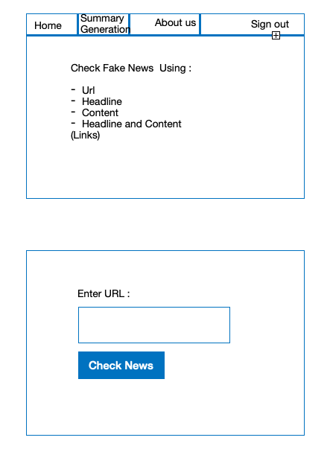

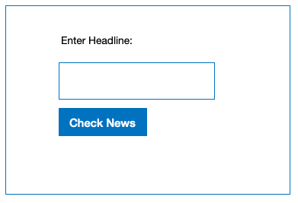

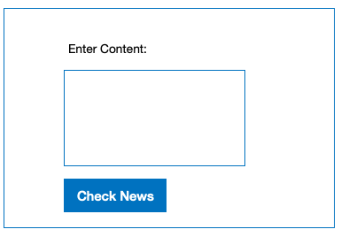

**Software Architecture Used : MVT**

MVT architecture is the software design pattern used by the Django web framework. It stands for Model - View - Template.

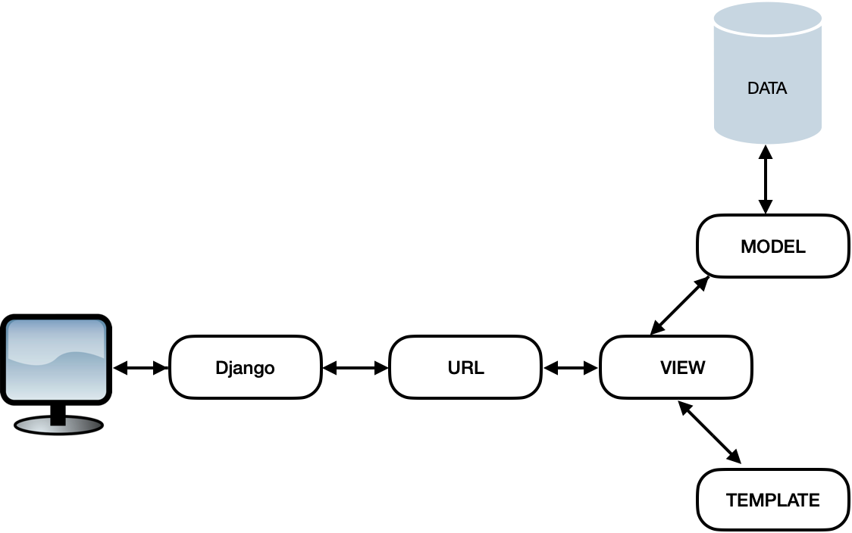

**Model :**

It has the functionality of providing the interface for the data stored in the database.

**Template:**

Templates are responsible for the entire User Interface completely. It handles all the static parts of the webpage along with the HTML, which the users visiting the webpage will perceive.

**View:**

It sees the user request, retrieves appropriate data from the database, then renders back the template along with retrieved data. Business logic is written in view.

**Database design :-**

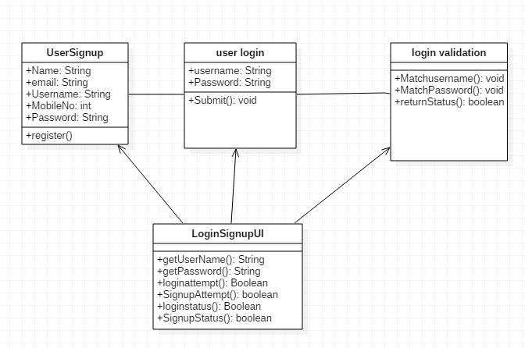

**UI**

